**Monitoring**

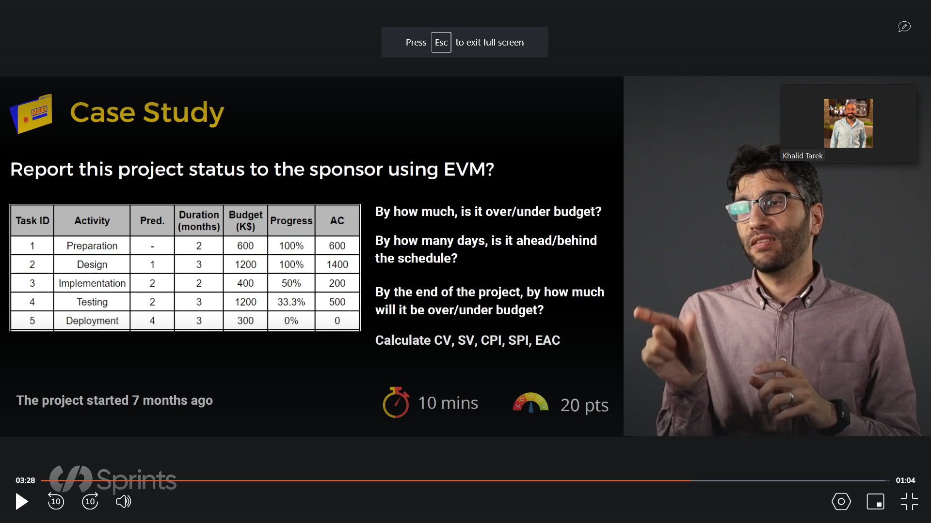

* **By how much is it over/under budget?**

Currently the project is under budget.

* **By how many days is the project ahead/behind the schedule?**

The project is currently up to date, since the project started 7 months ago and both task 1 & 2 are finished taking 5 months. Task 3 is 50%, as a result we assume that only 1 month has ben taken for this task, and the same assumption was presumed for task 4, which is one month based on 33%.

* **By the end of the project, how much will it be over/under budget?**

It will be over by 200,000$.

* **CV =** 200,000$
* **SV =** 2,700,000$
* **CPI =** 0.95
* **SPI =** 1.125
* **EAC =** 3,900,000$